Katie Grant

AVT 318: Graphic Design History

March 3, 2021

The legacy of the Bauhaus Movement has become the décor of our daily lives. The movement’s champion of form and function while embracing industrialization infused the movement’s artistry into homes and everyday lives. “The continuing relevance of the Bauhaus is perhaps primarily due to the way it broke down the walls between artistic disciplines and blurred the boundaries between different categories of objects. Many artists today instinctively give their works a utilitarian function, thereby modifying their relationship with art on a profound level” (Billé, 241). Producing for the masses with both skill and artistry, as well as forced globalization at the hand of the Nazi party, makes the Bauhaus Movement uniquely situated for far reaching and long-lasting impact. “The Bauhaus produced an incredible array of artefacts, from angle poise lamps to chess sets, all distinguished by their functional and elegant construction. They were simple and useful, and their simplicity made them beautiful. In an era of ornamentation, their streamlined appearance was revolutionary” (Cook).

To understand the influence of the Bauhaus movement, we must understand how the movement came to be. The Staatliches Bauhaus was a German art school that opened in 1919 and lasted 14 years, closing in 1931. Literally translated as “building house”, the school married arts and industry, opposing the ornate and opulent styles of Art Nouveau and Art Deco that preceded it. The Bauhaus school was more than just a school; it preached a way of thought and a new view of the world. Bauhaus artists favored linear and geometrical forms, while floral or curvilinear shapes were avoided. Only line, shape and color mattered. Anything else was unnecessary and needed to be reduced (Roseanne). In short, the Bauhaus applied the adage “form follows function”, infusing art into the everyday. As the *Brittanica* states, the emphasis was on “producing functional and aesthetically pleasing objects for mass society rather than individual items for a wealthy elite” (“Bauhaus”).

The school was founded in Weimar, Germany by Walter Gropius. Walter Gropius “repeatedly emphasized that the Bauhaus emerged from the spirit of the *Deutscher Werkbund*… [a way] to create a practical, effective connection between commerce, craftmanship and industry, and the designing artist” (Siebenbrodt 16). The school itself required students to take a 6-month preliminary course, followed by 3 years of workshop courses. These courses included carpentry, metal, pottery, stained glass, wall painting, weaving, graphics, typography, and stagecraft. The workers would earn a journeyman’s degree upon completion (“Bauhaus”). The result of a practical degree meant that graduates often joined the workforce and helped to bring the Bauhaus style into the industry and by extension, into people’s homes.

The Bauhaus school admitted women, who were rarely granted opportunities to pursue art education in Germany. The first class of applicants in 1919 had more women than men apply. Despite the theoretical attempt at equality, the Bauhaus school failed in execution. In Gropius’ greeting speech to the first class of the Bauhaus school he advocates, “Absolute equality but also absolutely equal obligation to the work of all craftsmen.” And in the same breath, the same speech, he goes on to say there is “No difference between the beautiful and the strong sex” (Müller 7-9). Despite the façade of gender equality, the flawed practice meant that teachers and leaders of the school primarily relegated women to the feminine art of weaving. Still, some found success even given these limitations, such as Gunta Stölzl. Another notable exception was Marianne Brandt, who focused on metalcraft, and is still regarded today as a foundational contributor to Bauhaus design. According to a 2010 survey at the Museum of Modern Art, “the weaving workshop became one of the only departments in the Bauhaus that was financially viable...along with the metal workshop, which was led by Marianne Brandt.” (Capps).

Building financially viable programs contributed in two ways to the school and overall Bauhaus movement. In a literal sense, they produced revenue streams that supported the school and allowed for continuing education that was self sufficient to some degree. Secondly, by producing and selling Bauhaus artisan goods, these goods were delivered into the hands of consumers, furthering the spread of Bauhaus ideals. The goods created by Bauhaus artists were consumed by the population and absorbed as everyday products in homes. With exposure and demand came recognition, and the ability to mass produce goods meant a wide audience for consumption. When the school moved to Dessau in 1925, “Bauhaus wallpaper became the school’s bestselling product. At last, here was an art school which could actually pay its way” (Cook).

Escaping the increasingly conservative political landscape of Weimar, the school’s move to Dessau, Germany was marked notably by a new building (see fig. 1). While Gropius, in his manifesto outlining his teaching program in Weimar placed all creative work within the compass of architecture, the school had no dedicated department until the move to Dessau (Billé, 159). The Dessau building “contained many features that later became hallmarks of modernist architecture, including steel-frame construction, a glass curtain wall, and an asymmetrical, pinwheel plan, throughout which Gropius distributed studio, classroom, and administrative space for maximum efficiency and spatial logic” (Winton). The asymmetrical pinwheel was in part a tribute to the prominence of the Junkers aircraft manufacturer that was a leading contributor to industry in Dessau. This homage to industry is fitting, considering prominent faculty László Moholy-Nagy’s success at pursuing a more Constructivist curriculum for the school, “with more resources devoted to art forms that could serve a modern industrial society” (Eskilson, 217).

Architecting the Dessau building was a reflection of the Bauhaus’ school’s new direction. Under the champion of teacher Maholy-Nagy, the curriculum turned toward functional art that could serve a modern industrial society. This meant that in addition to the study of architecture itself, it was also the objects within buildings that the artists focused on. Fixtures were prime targets to transform using Bauhaus principles into utilitarian but also beautiful works. The Model B3 chair (See fig. 2), also known as the Wassily Chair, was designed by Marcel Breuer and named for his colleague Wassily Kandinsky. This chair has a tubular metal frame, adorned with strips of fabric or leather to construct a minimalist, exposed chair. As Eskilson describes it, “Its spare steel frame forms cubic shaped that seem to pass through each other, its beauty resting in proportion and the balance of simple forms” (217). The chair as iconic legacy of the Bauhaus school “has been mass-produced since the 1950s” (Hartov). Even today, a quick search will easily yield millions of results, from YouTube videos touting “How to Identify…Wassily Chairs Authenticity” to the many sellers who offer replicas of the chair. The impact of this chair is evident in its legacy; a beautiful form that people cherish and sit in today.

Graphics and typography also flourished in the new location of the school, turning from the traditional fine arts instruction to instead focus on commercial application. Despite blocky forms and solid blocks, the arrangement of typography allowed for kinetic infusion into posters and balance. Herbert Bayer exemplifies the style of the time with posters that show blocked colors and text, but turned and made perpendicular to each other to draw the eye across the composition (see fig. 3) (Bergdoll, 174). Sans serif type was highly favored and thought to represent the spirit of the machine age and also served simplicity to complement photography. Typography, coupled with the increased emphasis on technical execution of photography led to the birth of the new typophoto visualization style. Working together, typography and photography could create a cohesive, unified message across planes and medium.

One of the most famous typefaces created by the Bauhaus was Herbert Bayer’s Universal (see   
fig. 4). Universal was characterized by even weight thickness, symmetry, and perfect clarity. The letter forms themselves were designed with great care, from the reflective “n” and “u” letterforms to standardized angles that strokes adhere to while composing the letterforms. Every aspect was intentional. Universal was designed to be used with a single case letterset (lowercase) that would save printers money without sacrificing readability. Universal inspired one of the most influential sans serif fonts of all, Futura. While Futura was not made in Bauhaus, the original intention was to take pure geometric forms and allow for readability. However, multiple iterations left Futura deviating from the pure geometry because “the purest geometric forms neither appeared beautiful as individual shapes nor connected fluidly with one another” (Eskilson, 224). In the end Futura deviates from those pure geometric intentions with some subtle strokes to aid readability, but is still heavily inspired by the same principles espoused by Bauhaus. Futura is still widely used today, as evidenced by its use by the popular food magazine and empire, *Bon Appetit*. Even today, we as consumers are exposed to Bauhaus-inspired typography commonly, further solidifying its place in our everyday, in all aspects of form and function. As Whitford puts it, “The look of the modern environment is unthinkable without it. It left an indelible mark on activities as various as photography, architecture, and newspaper design” (201).

The prominence and success of the Bauhaus school meant that it also drew the eye of a darker movement rising in Germany. The National Socialist German Workers’ Party, colloquially known as the Nazi Party, did not support the design and free-thinking style of the Bauhaus. “The Nazis saw the Bauhaus as representing ‘foreignness’ and viewed their designs as distinctly un-German and criticized their modernist style, so when the party gain control of Dessau city council in 1931, they moved to close the school” (“100 Years of Bauhaus”). The director at the time, Ludwig Mies van der Rohe fought to keep the school open and moved the Bauhaus school to Berlin, but the attempt at survival was short-lived. Suspected of producing anti-Nazi propaganda, the converted neglected factory was raided by the Gestapo. Despite fighting to reopen the school for a time, Mies ultimately decided to close the school voluntarily, and he himself emigrated to the United States.

Mies was far from the first from the Bauhaus School to emigrate to the United States from Germany, nor the last. Many architects in particular “worked or tried to work for the National Socialist government in the years following Hitler’s ascent to power. Only once it because clear that the Nazis were ruling modern architecture out of their agenda did these architects look for an exit” (Talesnik). Those that preceded Mies included Walter Gropius, Marcel Breuer, Josef Albers, and László Moholy-Nagy, though this list omits plenty of strong emigrant contributors to the spread of Bauhaus. Walter Gropius was announced the Chairman of the School of Architecture at Harvard in 1937, while others went on to be associated with other educational institutions including Yale and the Illinois Institute of Technology. Those in teaching positions went on to influence a new generation of students, and “the impact [of their teaching] is still apparent today especially in the area of foundation courses taught in art and architecture programs” (Edwards, 136-7).

The impact of Bauhaus was far-reaching, and was celebrated in the United States as early as 1962, where cosmopolitan art collector Katherine Dreier included Bauhaus artists at the Brooklyn Museum exhibit ‘International Exhibition of Modern Art’ (Powers 188). America welcomed the artists, although the new landscape proved different from Germany, for even the greats of the Bauhaus school. Gropius, together with Pietro Belluschi and Emery Roth & Sons created the Pan Am Building (now MetLife Building) in New York City, which is famously recognized as the building New Yorkers would most like to see demolished, but still, it stands (Powers, 207-208). Mies Van Der Rohe famously designed the Seagram Building on Park Avenue, one of the first buildings in New York “to externally articulate the structural qualities of a building” and from which the modern skyscraper has taken derivation from (“Manhattan: A homage to Bauhaus”). Even with powerful symbols of the Bauhaus still visible on the New York City skyline today, at the time, the Bauhaus movement was not escaped from the German political associations that drove it there. “Political issues that had been part of the school’s history, and which still threatened to break out in the United States, were deliberately played down in order to avoid immediate conflict, while the reception in the American press in 1938-39 demonstrated that conservative, xenophobic or anti-Semitic opponents were still at large.” (Powers, 191)

Irony lies in the execution of the National Socialist Party’s attempt to squash the Bauhaus school of thought and ideas. In regarding the ‘foreignness’ of the school, they instead drove the free thinkers, both teachers and students of the school, abroad. “By 1933 [Bauhaus] was well known in interested circles of most of Europe; its forced closure and the subsequent emigration of many former students and staff then ensured that it would quickly become famous throughout the world” (Whitford 197). In persecution, the National Socialist Party contributed to the spread of these ideas and spread the artistry and opportunities for manufacturing to other countries. While many departed for Western Europe or the United States, those in later years would move “East to the Soviet Union and later to “other” countries like Chile, China, Hungary, Japan, Kenya, Mexico, North Korea, and Turkey” (Talesnik).

The political pressure of the Socialist Party was a key driving factor in the global movement of those trained and practicing application of the teachings of the Bauhaus school, which in turn, helped the spread of Bauhaus itself. This globalization meant that the Bauhaus principles were applied to different countries and markets, enabling worldwide adaptation that may otherwise have been centralized in Germany. The influence of the Bauhaus movement has seen long and far-reaching impact on modern sensibilities, despite the school’s fairly modest 14-year history. Yet the contributors, teachers, and students of the Bauhaus movement managed a legacy that still pervades our everyday lives.

While the school existed, the emphasis on practicality and affordable, simple design contributed to sustaining the school through profits of items sold. The pressure and persecution of the Nazi Party against the “foreignness” of the Bauhaus drove the minds of the school abroad, ironically furthering the global adaptation of the Bauhaus movement. It was a movement made for success, when practical, mass-produced artistry was able to reach many new markets, aided by the globalization forced by Nazi hands. Embracing industrialization and commercialization meant that products were both affordable and beautiful; art made for everyday consumption. These everyday objects have become entrenched in our everyday lives and families, to become our very own history. Sale of such accessible items such as the Wassily Chair, or the influence of architecture on buildings that still stand erect today are simply evidence of the Bauhaus that has become entrenched in culture itself, much less the culture that continues to produce. As written in *The Spirit of the Bauhaus,* “Almost all contemporary designers could claim direct descent from the Bauhaus in one respect or another—whether in textures, spatial relationships, creation of environments or interplay of form and function, the desire for total or the urge to democratize” (Billé, 241). Thus, this historical context of the Bauhaus movement not only has impact in the items we consume and live with, but leaves an influential legacy on the future creators who continue to manipulate the principles of Bauhaus.

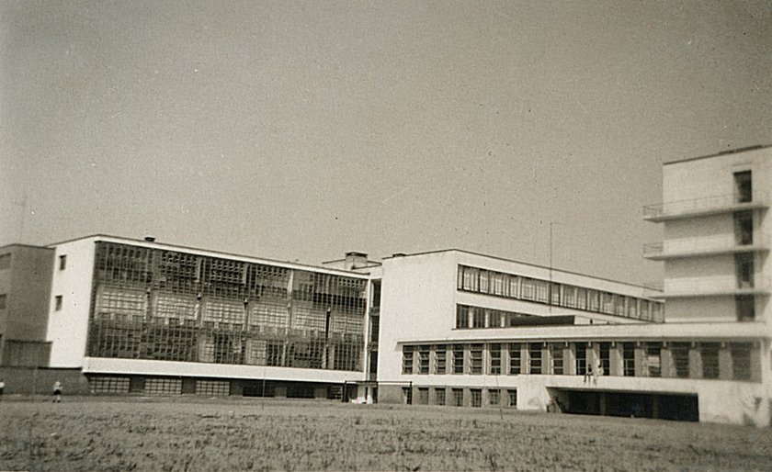

Fig. 1: Dessau Building. Bauhaus Dessau. 24 Apr. 2021,  
https://www.bauhaus-dessau.de/en/architecture/bauhaus-building.html

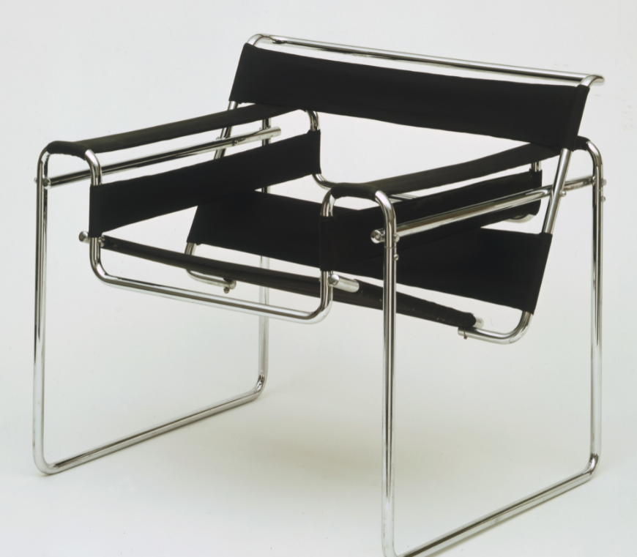

Fig 2: Wassily Chair. Modern Museum of Art. 24 Apr. 2021,   
https://www.moma.org/collection/works/2851.

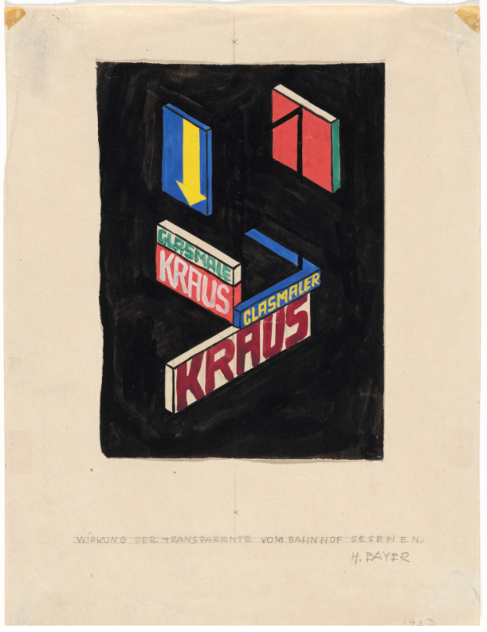

Fig. 1: Effect of Banners Seen from the Train Station (Wirkung der Transparente   
vom Bahnhof gesehen). Modern Museum of Art. 24 Apr. 2021,   
https://www.moma.org/collection/works/280168.



Fig. 4: Universal Typeface. Encyclopedia.Design. 24 Apr. 2021,   
https://encyclopedia.design/2021/04/22/herbert-bayer-universal-typeface.

Works Cited

“Bauhaus.” *Brittanica,* 29 May 2020, www.britannica.com/topic/Bauhaus.

Bergdoll, Barry, and Leah Dickerman. *Bauhaus 1919-1933: Workshops for Modernity*. New York: Museum of Modern Art, 2009.

Billé, Raphaèle et al. *The Spirit of the Bauhaus*. Thames & Hudson, London 2018.

Capps, Kriston. “The Women of the Bauhaus” *Bloomberg CityLab,* 15 Mar. 2019, https://www.bloomberg.com/news/articles/2019-03-15/the-false-equality-of-the-bauhaus.

Cook, William. “The Endless Influence of the Bauhaus.” *BBC,* 10 Nov. 2017, www.bbc.com/culture/article/20171109-the-endless-influence-of-the-bauhaus.

Edwards, M. Jean, MFA. “Lessons of the Bauhaus” *Journal of Interior Design* 44.3 (2019): 134-140.

Eskilson, Stephen J. *Graphic Design A New History.* 3rd ed., 2007. Yale University Press, 2017.

Hartov, Oren. “The Bauhaus Is One of the Most Influential Design Movements in History.” *Gear Patrol,* 30 Jun. 2020, www.gearpatrol.com/briefings/a609440/influence-of-the-bauhaus-movement.

“Manhattan: A Homage to Bauhaus” *Open Journal.* 14 Aug. 2019, http://openjournal.com.au/manhattan-a-homage-to-bauhaus.

Müller, Ulrike. *Bauhaus Women.* Flammarion, S.A. Paris, 2009.

“100 Years of Bauhaus: What it is and How it Shaped Today’s Design Industry.” *Amara,* 14 May 2019, www.amara.com/us/editorial/styling/bauhaus-design-movement.

Powers, Alan. *Bauhaus Goes West.* Thames & Hudson Ltd, London 2019.

Roseanne. “The Characteristics of Bauhaus.” *Catawiki,* 31 Aug. 2020,www.catawiki.com/stories/5263-the-characteristics-of-bauhaus.

Siebenbrodt, Michael, and Lutz Schobe. *Bauhaus.* Parkstone International, 2009.

Talesnik**, Daniel.**“The Third Migration.” Les Cahiers de la recherche architecturale urbaine et paysagère [En ligne] Sept. 2018

Whitford, Frank. *Bauhaus.* Thames and Hudson Ltd, London, 1984.

Winton, Alexandra Griffith. “The Bauhaus, 1919-1933.” *The Met,* Oct. 2016, www.metmuseum.org/toah/hd/bauh/hd_bauh.htm.